

**DEPARTMENT OF ELECTRONICS AND COMMUNICAION ENGINEERING**

**Subject: DIGITAL ELECTRONICS& MICROCONTROLLERS (ECH308B-T/P)**

**Branch: CSE**

**Course: B.Tech 5th SEM**

**TUTORIAL -6: Combinational Circuits**

CO3. Analyze different types of digital electronic circuits using various mapping and logical tools and know the techniques to prepare the most simplified circuit using multiple mapping and mathematical methods.

1. Implement Full Subtractor using 4*1 MUX.
2. The Boolean function realized by the logic circuit shown is

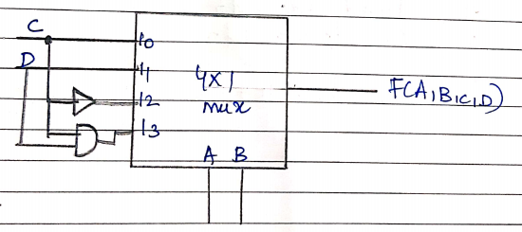

1. Implement the full adder by using 1:8 Demultiplexer?